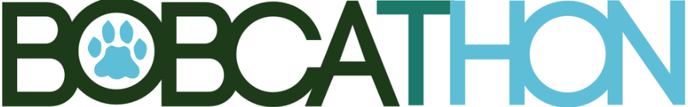
Dear _____,

First and foremost, thank you so much for your interest in the support of BobcaThon and the Ronald McDonald House of Central Ohio. The Ronald McDonald House that we benefit is the largest in the world, with 137 guest rooms. It is conveniently just steps away from the Nationwide Children’s Hospital in Columbus, Ohio. Every night, mothers, fathers, brothers, and sisters stay in the house, allowing it to be their home-away-from-home for as long as their child is being treated at the hospital. The RMHC is free of charge for these families, allowing them to focus solely on the health and betterment of their child, instead of on their financial woes. However, the RMHC is more than just a place to stay; it provides families with the ability to support each other and connect, while being close to their children in times of ill health.

Last year, BobcaThon had an amazing fundraising season, contributing $110,000 to add to our total of over $223,000 in our first four years of existence. This year, we have a goal of $116,000 and we ask for your support so that we can continue to help families and their children affected by serious and life-threatening illnesses.

To take action and support the children battling serious illnesses and their families by donating to BobcaThon, you can take one of two steps:
- Visit https://bobcathon20.everydayhero.com/us/_______
- Write a check payable to “BobcaThon” including my name, ____, in the memo line and send it back to me at ______ Athens, OH 45701.

Every cent donated goes straight to the Ronald McDonald House of Central Ohio and directly benefits the families staying there. Here are some numbers to show what impact BobcaThon has: $100 is enough for 25 new towels, $500 is enough to provide 25 nights of rest, and $1,000 is enough to provide breakfast for 1,693 people.

We hope that you will choose to join us in support of the RMHC!

For The Kids,

_____

